Tutorial 9
-------------------------------------------------------------------------------------------------------------
NAME : THORAT PUJA DHANAJI
BATCH : CE3(C)
PRN : B25CE1197

PROBLEM STATEMENT - Create a bar chart using Matplotlib to display the marks scored by a student in 5 different subjects. The chart should include appropriate labels for the x-axis (subjects), y-axis (marks), and a title.

ASSIGNMENT -
import matplotlib.pyplot as plt
x = ["Mathematics", "English", "Marathi", "History", "Geography"]
y = [99, 70, 89, 87, 97]
plt.bar(x, y, color='skyblue')
plt.title('Student Mark')
plt.show()

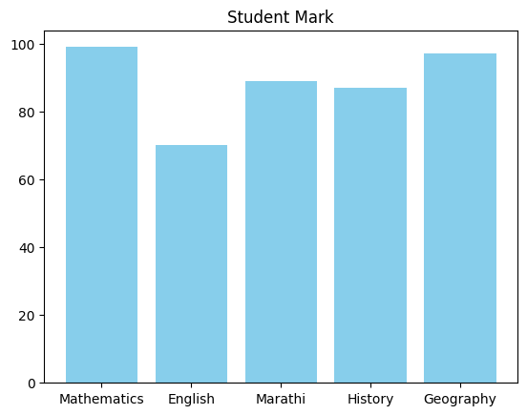

PRACTICE -

1) Creating a Simple Line Plot

import matplotlib.pyplot as plt
# Sample data
x = ["Mathematics", "English", "Marathi", "History", "Geography"]
y = [99, 70, 89, 87, 97]

# Create the plot
plt.plot(x, y)
# Add labels and title
plt.xlabel('X-axis')
plt.ylabel('Y-axis')
plt.title('Student Mark')

# Show the plot
plt.show()

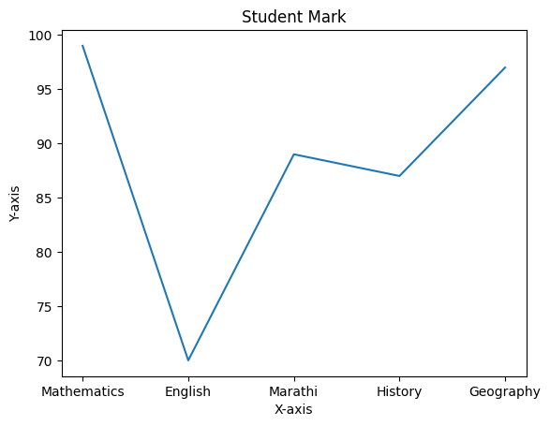

2) Scatter Plot
import matplotlib.pyplot as plt
x = ["Mathematics", "English", "Marathi", "History", "Geography"]
y = [99, 70, 89, 87, 97]
plt.scatter(x, y, color='red')
plt.title('Scatter Plot Example')
plt.show()

